**Naukri FastForward Privilege**

**Report Generation App**

***An Internship Report submitted in partial fulfilment***

***of the requirements for the degree of***

**Bachelor of Technology**

**In**

**Computer Science and Engineering**

**by**

**Prithwiraj Samanta**

***Under the supervision of***

**Dr Rashmi Panda**



**भारतीय सूचना प्रौद्योगिकी संस्थान राँची**

**INDIAN INSTITUTE OF INFORMATION TECHNOLOGY, RANCHI**

(An Institution of National importance under an act of Parliament)

(Ranchi - 834010), Jharkhand

***Department of Computer Science and Engineering***



**Indian Institute of Information Technology**

**Ranchi**

**Certificate**

This is to certify that the Internship Report entitled ”**Naukri FastForward Privilege Report Generation App**” is a Bonafede record of work carried out by **Prithwiraj Samanta,** under my supervision, for the partial fulfilment of the requirements for the award of the degree of **Bachelor of Technology (Honours)** in Computer Science and Engineering at the Indian Institute of Information Technology, Ranchi. The Internship Report has fulfilled all the requirements as per the regulations of the institute and in my opinion, reached the standard for submission.

**Dr Rashmi Panda**

**Assistant Professor**

**Indian Institute of Information Technology**

**Date: May 2022**

**Place: IIIT Ranchi**

Acknowledgement

I am greatly indebted to my internship project mentor Mr Himanshu Gupta(InfoEdge India Limited) for his invaluable guidance and encouragement throughout the course of this project. I would like to take this opportunity to express my sincere and profound gratitude to him.

I would also like to gratefully acknowledge the suggestions and discussions received from my supervisor Prof. Rashmi Panda.

My sincere thanks also go to all the faculty of CSE for their kind co-operation in all spheres during my project work. I would also like to thank all others whose direct or indirect help has benefited me during my stay at IIIT Ranchi.

Furthermore, I would like to thank all other friends and fellow students of IIIT Ranchi and particularly my CSE mates for sparing a great time throughout my B. Tech and very good support I received from them during my stay.

Last but not the least, I thank my parents and all my family members for the support and motivation they have provided throughout my project.

**Prithwiraj Samanta**

Abstract

The FastForward team of naukri.com generates a report for a paid user which contains statistical data that helps the user to understand the current job market trends, and competition at his/her level. This report is generated manually for each user so it takes a large amount of time and labour. The report is generated monthly so it does not have daily-updated statistics.

In this project, it has been proposed to automate the entire report generation process and provide the user with this report generation facility in form of an app that runs on Android, IOS, and Web. It will allow the user to generate the report at their will any number of times with updated trends within seconds. This app will gather data from various sources and display it to a user.

It is planned to integrate the Do-Select platform with this app to enable users to take skill tests based on their CV. This app will also act as an advertising point for other Naukri services. We will be using the latest multi-platform technologies for a seamless experience across various platforms.

Content

**Acknowledgement i**

**Abstract ii**

**List of Figures iii**

**List of Tables iv**

**1 Introduction 6**

**2 Implementation 8**

2.1 Comparative Analysis of Flutter and React-Native …………………..… 8

2.2 Data Flow in the Application ………………………………………….………... 12

2.3 Components in the Application ………………………………………………… 14

2.4 Integrate Flutter App into existing iOS App ……….……………………… 16

**3 Results and Discussion 17**

3.1 Result ……….……………………………………………………………………………….. 17

3.2 Discussion …...…………………………………………………………………………….. 18

**4 Conclusion and Future Work 19**

4.1 Conclusion ….………………………………………………………………………..…… 19

4.2 Future Work ………………………………………………………………………..……. 19

**Project Details v**

List of Figures

2.1 Data Flow in Application ……………………………………….…… 13

2.2 Component Diagram(Screens) ………….……………..…….…… 14

2.3 Component Diagram(Tabs) ………….………...………..…….…… 14

2.4 Communication Flow Diagram of Flutter and iOS App ….. 16

List of Tables

2.1 React-Native vs Flutter Analysis………………………………….… 8

**1**

Introduction

With the increase in diversity and competition of the job market the difficulty for finding a suitable job according to one need is increasing. The user needs a lot of statistics and an understanding of the market to get a job with a genuine CTC. The user also finds difficulty in knowing the trending skills needed to get hired and the right point of contact between job seekers and recruiters.

With the increase in the number of job seekers and the diversity of skills required to complete a task, recruiters are finding difficulty in getting the right candidate for the job. As the number of candidates increases recruiter finds it difficult to hire the best among the crowd. It takes a lot of time and labour to get a desirable candidate.

The naukri.com acts as all one platform where job seekers meet recruiters. The naukri.com also has a few premium services that help user boost their probability of finding the right job. One such service is Naukri FastForward. This service is for writing professional-level resumes that will make one stand out of the crowd. It also provides features to highlight your resume among the other seven crore candidates on naukri.com. As a part of the premium subscription, the FastForward team provides a special report on statistical data, profile performance, and hiring trends. This report takes a lot of effort to generate as it requires manual fetching of data from various departments.

This project is planned to automate the report generation process so that users can get the report at any time they want. There will be no limit to the number of times the user can generate this report. As of now, manual service provides one such report per month to the user.

This application will run on Android, IOS, and Web, displaying the following-

* Hiring across industry
* Hiring across the cross-functional area
* Hiring across cities
* Hiring across experience level
* Hiring and Recruitment trends
* Job applies relevance
* Top recruiters searching for the user
* Competitions in the industry
* Suggestions based on profiles
* Advertisement of other Naukri services

This application will be able to create a PDF of all the above data.

**2**

Implementation

* 1. **Comparative Analysis Flutter & React-Native**

Flutter and React-Native both are popular tools to create a multi-platform app. A comparative analysis has been made to ensure that the best tool is chosen to create the application. The tool has a great impact on maintenance time as well as the labor required.

*Table 2.1*

| Aspect | Flutter | React-Native |
| --- | --- | --- |
| What is it? | A portable UI toolkit for building natively-compiled apps across mobile, web, and desktop from a single codebase | A framework for building native applications using React |
| Official release | December 2018, Google I/O | March 2015, F8 Conference |
| Created by | Google | Facebook |
| Free and open source | Yes | Yes |
| Programming language | Dart | JavaScript |
| Popularity | 136,000 Stars on [GitHub](https://github.com/flutter/flutter) | 101,000 stars on [GitHub](https://github.com/facebook/react-native) |
| Hot Reload | Yes | Yes |
| Native performance | Great | Great |
| Effort | Less as most of the components are predefined.  Responsiveness is built-in. | More as we have to build from scratch, only a few components are predefined.  Responsiveness is not built-in. |
| Stability | Stable | Stable |
| Maintenance | Easy to maintain | Lots of dependency issues |
| Top apps made with this technology | Xianyu app by Alibaba, Hamilton app for Hamilton Musical, Google Ads app, Philips Hue, My BMW | Instagram, Facebook, Facebook Ads, Skype, Tesla |
| Time-to-market | Typically, much faster than native development. | Possibly as fast as development with Flutter. |
| Competitive advantage | * Great look and feel thanks to rich widgets * Rapidly growing community, and popularity * Excellent documentation with strong support from the Flutter team (which makes it easy to start developing with Flutter) * Improving Flutter for Web, offering the potential for one codebase across mobile and web platforms   Difficult to beat time-to-market length | * Many successful, prominent market players using React Native * A mature, vast community * Easy-to-learn technology * Plenty of tutorials and libraries, which allow quick and easy development   Code can be easily reused for both web app and desktop app development. |
| When it is not the best fit | If…   * Your app needs to support 3D Touch * The design of your app is platform-specific * Your app requires multiple interactions with an OS; or requires rare, little-known native libraries * You need a minimalistic UI, but rely on significant use of the phone hardware * You want to create an instant app (small-sized app)   If your app sounds like any of the above, it’s probably better you choose native app development. | If…   * Your app needs to handle tasks in the background * You require custom communication via Bluetooth * You want to create an app for Android only   In truth, if you want to build an iOS app and you know JavaScript, consider React Native – but if you want an Android-only app, it’s likely better to build natively with another team. Why? Right now, iOS has better support than Android. |
| UI | Flutter apps look as good on the up-to-date operating systems as they do on older versions.  Since they only have one codebase, the apps look and behave similarly across iOS and Android – but thanks to Material Design and Cupertino widgets, they can also imitate the platform design itself. How’s that possible?  Flutter contains two sets of widgets that conform to specific design languages: Material Design widgets implement Google’s design language of the same name; Cupertino widgets imitate Apple’s iOS design.  This means that your Flutter app will look and behave naturally on each platform, imitating its native components. | Application components look just like native ones (e.g., a button on an iOS device looks just like a native iOS button, and the same on Android).  The fact React Native uses native components under the hood should give you confidence that, after any OS UI update, your app’s components will be instantly upgraded as well.  That said, this can break the app’s UI but it happens very rarely.  If you want your app to look near-identical across platforms – as well as on older versions of an operating system (as Flutter achieves) – then consider using third-party libraries. They will enable you to use Material Design components, in place of native ones. |
| Sharing code | We can use the same codebase to ship native apps to five operating systems: iOS, Android, Windows, macOS, and Linux; as well as web experiences targeting browsers such as Firefox, Chrome, Safari, or Edge.  Flutter can even be embedded in cars, TVs, and smart home appliances.  Perhaps the single largest announcement in Flutter 2 is production-quality support for the web.  It can be used for:   * **Progressive Web Apps (PWAs)** that combine the web’s reach with the capabilities of a desktop app, * **Single Page Apps (SPAs)** that load once and transmit data to and from internet services. * **Existing mobile apps** – allowing Flutter apps to be run on a desktop. | ios **and** Android – but there are select libraries that allow you to use the same code to build **iOS, Android, web, and Windows10 apps**.  You can also extract shared code in mobile, desktop, and web apps, to a separate repository; treat it as a separate project; then inject it in the same way as another dependency.  This allows a developer to focus on writing code for a specific platform without having to consider compatibility with another one. |

**Why did we choose Flutter?**

This project requires creating a new application with the fastest development speed possible. Flutter provides built-in support of responsive UI along with a large library of predefined widgets optimized for performance. There is a library available for creating graphs and charts as well as PDFs. It has a feature that allows to draw out any custom widgets using different mathematical curves. Its dependencies are auto-managed and can be upgraded using one command whereas React-Native suffers dependency issues making the development and maintenance difficult.

* 1. **Data Flow in the Application**

**State Management**

1. **Ephemeral State**

* Ephemeral state (sometimes called UI state or local state) is the state one can neatly contain in a single widget.
* Other parts of the widget tree seldom need to access this kind of state. There is no need to serialize it, and it doesn’t change in complex ways.
* In other words, there is no need to use state management techniques in this kind of state. All one need is a StatefulWidget.

1. **App State**

* State that is not ephemeral, that you want to share across many parts of one’s app, and that you want to keep between user sessions, is what we call application state (sometimes also called shared state).
* For managing app state, one will want to research one’s options. One’s choice depends on the complexity and nature of one’s app, one’s team’s previous experience, and many other aspects.

**Classes & Widgets for State Management**

1. **ChangeNotifier Class**

* ChangeNotifier is a simple class included in the Flutter SDK that provides change notification to its listeners.
* In other words, if something is a ChangeNotifier, you can subscribe to its changes.

1. **ChangeNotifierProvider Widget**

* ChangeNotifierProvider is the widget that provides an instance of a ChangeNotifier to its descendants.

1. **Consumer Widget**

* The consumer is the widget that allows its descendent to subscribe and listen to the events of ChangeNotifier Object.

1. **SharedPreference Class**

* Wraps platform-specific persistent storage for simple data.
* Data may be persisted to disk asynchronously, and no guarantee writes will be persisted to disk after returning.

**How State is managed in the application?**

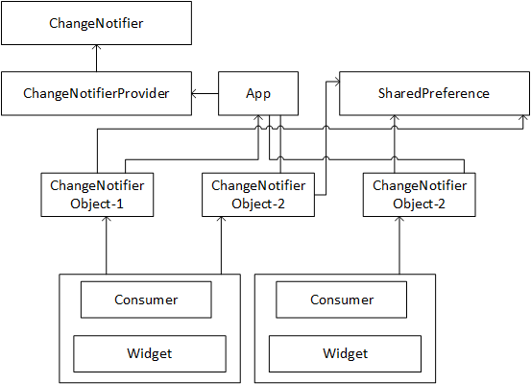

*Figure 2.1*

* 1. **Components in the Application**

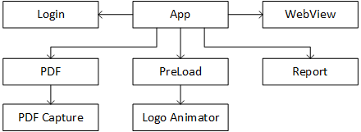

*Figure 2.2*

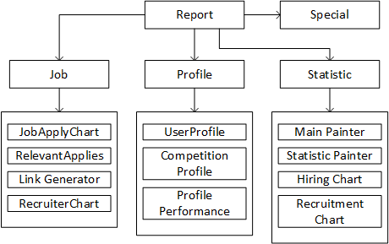

*Figure 2.3*

**Explanation**

* App Component has a Navigation Controller which controls the navigation of screens-Login, PDF, Preload, Report, and WebView.
* The report has BottomNavigation Controller which controls the tabs-Job, Profile, Special, and Statistic
* The report also has a controller for Sidebar(Sidebar Component not shown in the diagram)
* The cards and graphs that you will see in the App are individual components.
* The Login screen will be not there when we will in integrate it into iOS App as module.
  1. **Integration of Flutter App into existing iOS App**

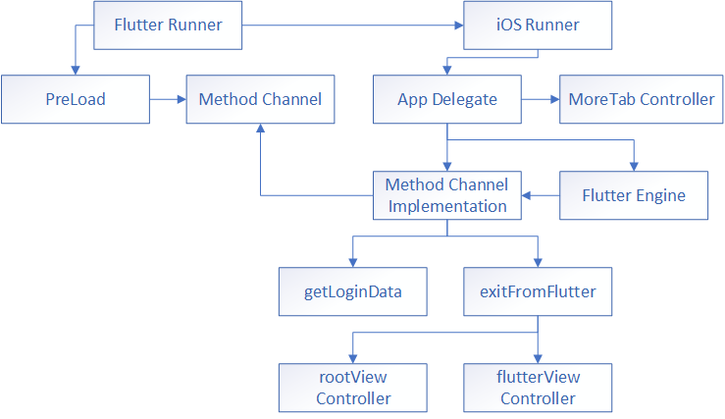

*Figure 2.4*

**Explanation**

* Flutter and iOS runner communicate with each other via module-app relationship
* In Preload screen we call getLoginData method which is defined in iOS app via method channel to get login data.
* When we want to exit from flutter inside iOS app, we call exitFromFlutter method from flutter, which is defined in iOS App
* exitFromFlutter replaces flutterViewController with rootViewController
* We run flutter inside iOS App using Flutter Engine, which is responsible for all the communication.

**3**

Results and Discussion

* 1. **Result**

An application has created an application that is capable of running across different platforms. Though it has been published our app in Google Play Store, Apple App Store, and hosted on the website it is not available for public use as it is still in the testing phase.

**Few Clips are taken from the Application**

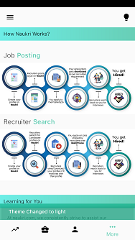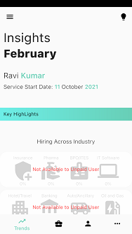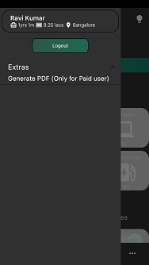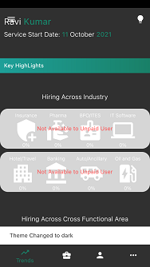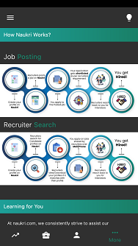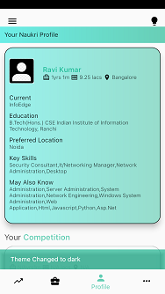

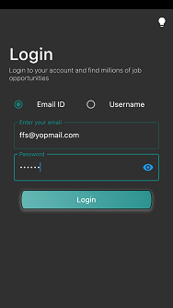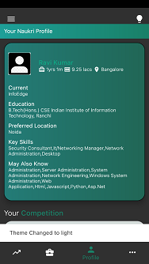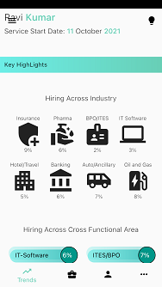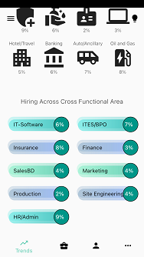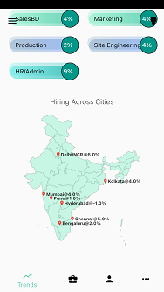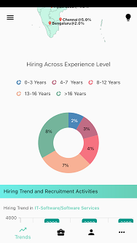

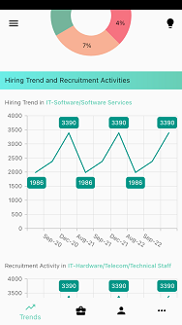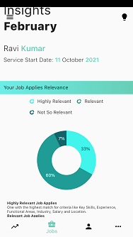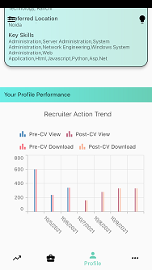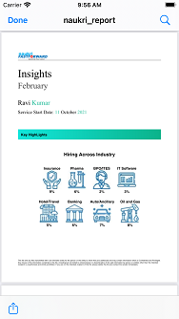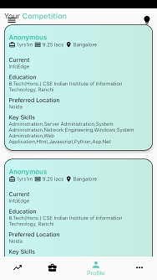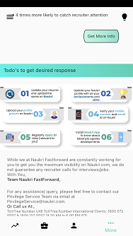

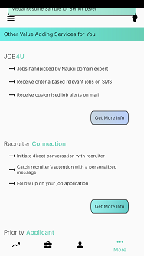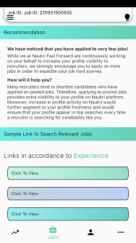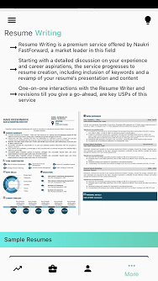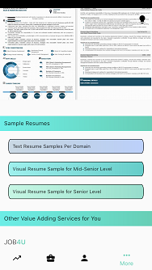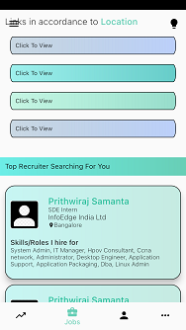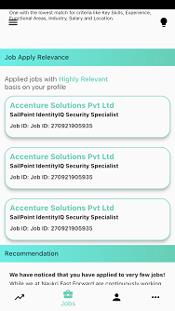

* 1. **Discussion**

The Graphical User Interface of the application has been created strategically so that users can view important statistics at first. There are warning present in the application that is due to null-safety of flutter. It can be assured that it will not affect the performance and user experience. The application may experience a few bugs as it is still in the testing phase, which will be solved gradually with updates.

We have successfully integrated the Flutter App into existing iOS App. Though some features will be not available until we migrate our dependencies accordingly.

**4**

Conclusion and Future Work

* 1. **Conclusion**

In this project, attempts have been made to create a Graphical User Interface with the highest possible optimization and smallest response time possible. The entire application is packed with a lot of statistical data to help the user in finding their dream job. This project also includes the development of a PDF engine for creating a beautiful PDF of all the statistics shown in the application.

* 1. **Future Work**

In Future, the project will continue to add more statistical data to the application when it will be available. The project will also continue the enhancement of the PDF engine to create a more beautiful and realistic PDF. Currently, the project is progressing towards the integration of the Do-Select platform with our app to provide skill and aptitude tests for users. It will be soon released in an upcoming feature update.

Project Details

|  |  |  |  |
| --- | --- | --- | --- |
| **Student Details** | | | |
| **Name** | **PRITHWIRAJ SAMANTA** | | |
| Registration Number | 2018UGCS002R | Roll No | CSE/02 |
| Email Address | psamanta.btech.cs18@iiitranchi.ac.in | Phone No (M) | 6204570243 |
|  | | | |
| **Project Details** | | | |
| **Project Title** | **FastForward Privilege Report Generation** | | |
| Project Duration | 6 months (approx.) | Date of reporting | 3 Jan 2022 |
|  | | | |
| **Organization Details** | | | |
| **Organization Name** | **InfoEdge India Limited** | | |
| Designation | Software Development Intern | | |
| Full postal address | Info Edge (India) Limited, B - 8, Sector - 132, Noida - 201304, India | | |
| Website address | http://www.infoedge.in/ | | |
|  | | | |
| **Supervisor Details** | | | |
| **Supervisor Name** | **Dr Rashmi Panda** | | |
| Designation | Assistant Professor (ECE Department) | | |
| Full contact address | IIIT Ranchi, Science and Technology Campus, Namkum, Ranchi - 834010 | | |
| Email address | [rashmipanda@iiitranchi.ac.in](mailto:rashmipanda@iiitranchi.ac.in) | Phone No (M) | 9861144096 |